**MESD LMS Documentation - View blogs/badges/notifications**

**Purpose**

To facilitate communication, recognize achievement and keep users informed about course activities.

**Usage**

* Log in as a **Learner.**

**Blogs**

1. Click on your icon/profile picture.
2. Click **Profile.**
3. Click **Blog entries** under **Miscellaneous**.

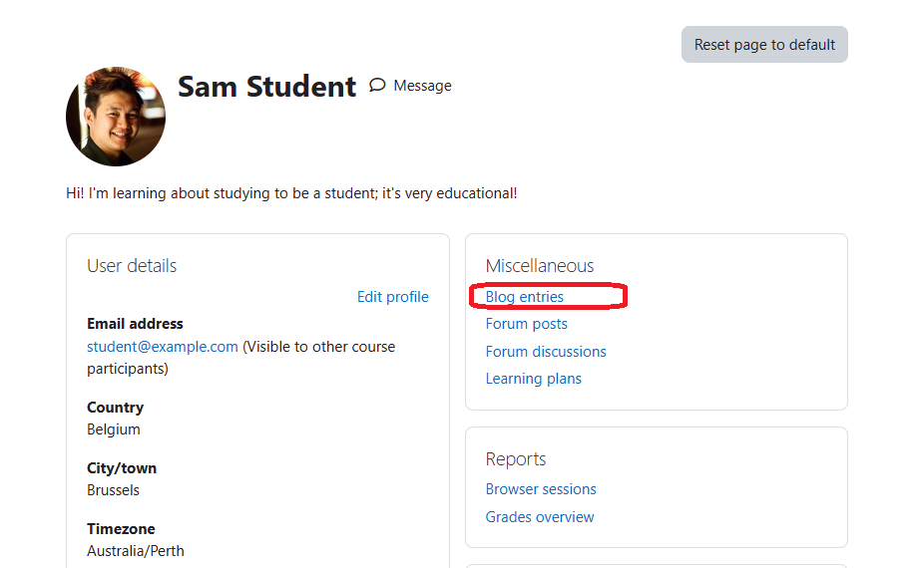

1. View your blog entries.

**Notifications**

1. Click on the bell icon next to your icon/profile picture.
2. Your notifications will be displayed there.

**Badges**

1. Click on your icon/profile picture.
2. Click **Preferences**.

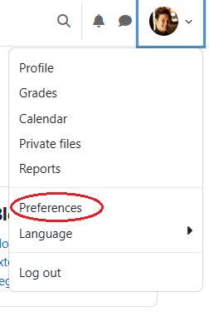

1. Click **Manage badges** under **Badges**.

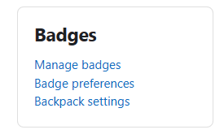

1. View your badges.